

**DEPT. Of Computer Science Engineering**

**SRM IST, Kattankulathur – 603 203**

**TITLE OF THE PROJECT : HOSPITAL MANAGEMENT SYSTEM.**

NAME : Viraj Joshi NAME : Vemuru Charith

Reg No: RA2111002010049 Reg no: RA2111002010054

Department : MECHANICAL Department : MECHANICAL

Section : A Section : A

Submitted to : Dr. A Vijay Vasanth

**AIM :-**

To create Hospital Management System using C programming.

**ABSTRACT :-**

A typical Hospital requires a management system to control it’s various operations such as maintaining account of all people in it’s domain of services, attending to various needs of patients and also achieving increased efficiency in the overall working of the Hospital itself. In the present time there is a great rush in hospitals, as these have become necessities for middle and upper class of the society. Now a days people are visiting often to the hospital because of this undecidable situation, even for a small issue we need to consult a doctor. The booking is manually done using paperwork and direct human language communication by mouth to the hospital management. This delays the information in the hospital. Booking is done through phone calls or through visit to the hospital or through online. The HOSPITAL MANAGEMENT SYSTEM aims to make simpler interaction between staff and patients. The system can be accessed by the admin and patients but the highest priority given to the admin that are allocated a login id and password. Hospital Management System provides various Appointments Booking Services, Managing the information of patients, Description regarding the Appointment booking. The proposed system enables automated data entry methods and enables fast and easy retrieval of guest records and data for fast reference activities.

**PROCEDURE :-**

Start the program with include stdio.h, and the whole program consists of words so we should also include string.h. Start the program with char name and char disease, and followed by integer function for age phone number etc.

Should use the void functions like read,add,view,search,edit,delete,show etc.

To make the pattern of hospital management system we used some for loops which are used for the user to select the choice in the data.

We had used else if functions to make the choices available to add data, view data, delete data etc.

For the thing to add data of patient we used printf and gets functions to get the data from user. Through printf we had included the name age cabin number and phone number details in our data.

After that we had used void view to see the data of the patients entered by using outs and printf function.

And next we had used void edit through edit the data on the certain option.

We used if and else if statements with printf and scanf function we made the option to modify the data.

And then we used void search to find the particular details of a patient by starting with int and char, and with if scanf and printf we specified to get the data of char or integer which is available in the option and it shows invalid if the data not available and data shown wrong and also valid function it prints as not found. We use puts to be clear that the required data will be shown.

And next by using void delete function at first it shows the what to be deleted by using printf and by using if statement with while loop include makes the data specified and used else if statements to delete the remain data not specified in the while loop, and used else to print invalid in case of data not found.

At last we used void read function to open the file simply to save data with fopen, this makes to create empty file to open the data, in the next execution of program and used printf to I JUST CREATED IT and followed by void write with fopen again and end the program with fclose.

**PROGRAM** :-

#include<stdio.h>

#include<string.h>

struct ad

{

    char name[30];

    char disease[30];

    int cabin,phone,age;

} x[100];

int n,i,j=0,a=0,sum=0,g,flag,num;

void read();

void add();

void view();

void search();

void edit();

void del();

void show();

int main()

{

    read();

    int c,i,q;

    printf("Simple Hospital Management System\n");

    int m,n;

//making out the pattern

    for(m=1; m<=4; m++)

    {

        for(n=1; n<=5; n++)

            printf(" ");

        for(n=1; n<=m-1; n++)

        {

            printf(" ");

        }

        for(n=1; n<=4-m+1; n++)

        {

            if(n==4-m+1 || m==1 || m==4)

                printf("*");

            else

                printf(" ");

        }

        for(n=1; n<=4-m+1; n++)

        {

            if(n==1 ||m==1 || m==4)

                printf("*");

            else

                printf(" ");

        }

        printf("\n");

    }

    while(c!=6)

    {

        printf("**Enter your choice**\n\n1. Add Information\n2. View Information\n3. Search\n4. Edit Information\n5. Delete Information\n6. Exit\n\nOption=");

        scanf("%d",&c);//choice for option

        fflush(stdin);//making it clear

        if(c==1)//add

        {

            system("cls");

            add();

        }

        else if(c==2)//view

        {

            system("cls");

            view();

        }

        else if(c==3)//search

        {

            system("cls");

            search();

        }

        else if(c==4)//edit

        {

            system("cls");

            edit();

        }

        else if(c==5)//delete

        {

            system("cls");

            del();

        }

        else if(c==6)

        {

            write();

            return 0;

        }

        else

        {

            system("cls");

            printf("\n\nInvalid input , try again by using valid inputs");

        }

        printf("\n\n");

    }

}

void add()

{

    printf("\n\n");

    printf("Already data inputed on the database =%d\n\n",num);//how many inputs

    printf("How many entry do you want to add=\n");

    scanf("%d",&n);

    sum=n+num;

    for(i=num,j=0; i<sum; i++)

    {

        printf("\n");

        fflush(stdin);

        printf("Enter patient's Name = ");

        gets(x[i].name);

        fflush(stdin);

        printf("Enter disease = ");

        gets(x[i].disease);

        fflush(stdin);

        printf("Enter the age = ");

        scanf("%d",&x[i].age);

        fflush(stdin);

        printf("Enter cabin no = ");

        scanf("%d",&x[i].cabin);

        fflush(stdin);

        printf("Enter phone number = ");

        scanf("%d",&x[i].phone);

        fflush(stdin);

        printf("\n");

        j++;

        a++;

        num++;

    }

}

void view()

{

    for(i=0; i<num; i++)

    {

        printf("\n");

        printf("Serial Number=%d\n",i);

        printf("Name = ");

        puts(x[i].name);

        printf("Disease = ");

        puts(x[i].disease);

        printf("Cabin no = %d\nPhone number = 0%d\nAge=%d",x[i].cabin,x[i].phone,x[i].age);

        printf("\n\n");

    }

}

void edit()

{

    int q,p;

    fflush(stdin);

    printf("What do you want to edit ?\n");

    printf("Enter your option\n");

    printf("1.Name\n2.Disease\n3.Age\n4.Cabin\n5.Phone no.\n");

    printf("Option=");

    scanf("%d",&q);//option

    if(q<=5)

    {

        printf("Enter the serial no of that patient= (0 - %d)=",num-1);

        scanf("%d",&p);//serial number

        if(p<num)

        {

            if(q==1)

            {

                fflush(stdin);

                printf("Enter the new name=");

                gets(x[p].name);

            }

            else if(q==2)

            {

                fflush(stdin);

                printf("Enter the new Disease=");

                gets(x[p].disease);

            }

            else if(q==3)

            {

                fflush(stdin);

                printf("Enter the new Age=");

                scanf("%d",&x[p].age);

            }

            else if(q==4)

            {

                fflush(stdin);

                printf("Enter the new Cabin no=");

                scanf("%d",&x[p].cabin);

            }

            else if(q==5)

            {

                fflush(stdin);

                printf("Enter the new Phone no =");

                scanf("%d",&x[p].phone);

            }

        }

        else

        {

            printf("\n\nInvalid Serial \nTry Again !!\n\n");

        }

    }

    else

    {

        printf("\n\nInvalid option\nTry Again!!\n\n");

    }

}

void search()

{

    int s,h,f;

    char u[100];

    printf("By what do you want to search ?\n");

    printf("1.Serial no.\n2.Name\n3.Disease\n4.Cabin no.\n5.Phone no.\n6.Age\n\nOption = ");

    scanf("%d",&h);

    if(h==1)

    {

        printf("Enter Serial number of the patient=");

        scanf("%d",&s);

        if(s<num)

        {

            printf("\n");

            printf("Serial Number=%d\n",s);

            printf("Name = ");

            puts(x[s].name);

            printf("Disease = ");

            puts(x[s].disease);

            printf("Cabin no = %d\nPhone number = 0%d\nAge = %d",x[s].cabin,x[s].phone,x[s].age);

            printf("\n\n");

        }

        else

            printf("\n\nNot Found\n\n");

    }

    else if(h==2)//problem is here.........

    {

        int f=1;

        fflush(stdin);

        printf("Enter your name=");

        gets(u);

        fflush(stdin);

        for(g=0; g<num; g++)

        {

            if(strcmp(u,x[g].name)==0)

            {

                printf("\n");

                printf("Serial Number=%d\n",g);

                printf("Name = ");

                puts(x[g].name);

                printf("Disease = ");

                puts(x[g].disease);

                printf("Cabin no = %d\nPhone number = 0%d\nAge = %d",x[g].cabin,x[g].phone,x[g].age);

                printf("\n\n");

                f=0;

            }

        }

        if(f==1)

            printf("\nNot Found\n");

    }

    else if(h==3)

    {

        int f=1;

        fflush(stdin);

        printf("Enter Disease = ");

        gets(u);

        fflush(stdin);

        for(g=0; g<num; g++)

        {

            if(strcmp(u,x[g].disease)==0)

            {

                printf("\n");

                printf("Serial Number=%d\n",g);

                printf("Name = ");

                puts(x[g].name);

                printf("Disease = ");

                puts(x[g].disease);

                printf("Cabin no = %d\nPhone number = 0%d\nAge = %d",x[g].cabin,x[g].phone,x[g].age);

                printf("\n\n");

                f=0;

            }

        }

        if(f==1)

            printf("\nNot Found\n");

    }

    else if(h==4)

    {

        int f=1;

        printf("Enter Cabin number = ");

        scanf("%d",&f);

        for(g=0; g<num; g++)

        {

            if(f==x[g].cabin)

            {

                printf("\n");

                printf("Serial Number=%d\n",g);

                printf("Name = ");

                puts(x[g].name);

                printf("Disease = ");

                puts(x[g].disease);

                printf("Cabin no = %d\nPhone number = 0%d\nAge = %d",x[g].cabin,x[g].phone,x[g].age);

                printf("\n\n");

                f=0;

            }

        }

        if(f==1)

            printf("Not Found\n\n");

    }

    else if(h==5)

    {

        int f=1;

        printf("Enter Phone number = ");

        scanf("%d",&f);

        for(g=0; g<num; g++)

        {

            if(f==x[g].phone)

            {

                printf("\n");

                printf("Serial Number=%d\n",g);

                printf("Name = ");

                puts(x[g].name);

                printf("Disease = ");

                puts(x[g].disease);

                printf("Cabin no = %d\nPhone number = 0%d\nAge = %d",x[g].cabin,x[g].phone,x[g].age);

                printf("\n\n");

                f=0;

            }

        }

        if(f==1)

            printf("Not Found");

    }

    else if(h==6)

    {

        int f=1;

        printf("Enter Age = ");

        scanf("%d",&f);

        for(g=0; g<num; g++)

        {

            if(f==x[g].age)

            {

                printf("\n");

                printf("Serial Number=%d\n",g);

                printf("Name = ");

                puts(x[g].name);

                printf("Disease = ");

                puts(x[g].disease);

                printf("Cabin no = %d\nPhone number = 0%d\nAge = %d",x[g].cabin,x[g].phone,x[g].age);

                printf("\n\n");

                f=0;

            }

        }

        if(f==1)

            printf("Not Found\n\n");

    }

    else

        printf("\n\nInvalid input\n\n");

}

void del()

{

    int f,h;

    printf("Enter the serial number of the patient that you want to delete=");

    scanf("%d",&f);

    if(f<num)

    {

        printf("What do you want ?\n");

        printf("1.Remove the whole record\n2.Remove Name\n3.Remove Disease\n4.Remove age\n5.Remove Cabin\n6.Remove phone number\nOption = ");

        scanf("%d",&h);

        if(h==1)

        {

            while(f<num)

            {

                strcpy(x[f].name,x[f+1].name);

                strcpy(x[f].disease,x[f+1].disease);

                x[f].age=x[f+1].age;

                x[f].cabin=x[f+1].cabin;

                x[f].phone=x[f+1].phone;

                f++;

            }

            num--;

        }

        else if(h==2)

        {

            strcpy(x[f].name,"Cleared");

        }

        else if(h==3)

        {

            strcpy(x[f].disease,"Cleared");

        }

        else if(h==4)

        {

            x[f].age=0;

        }

        else if(h==5)

        {

            x[f].cabin=0;

        }

        else if(h==6)

        {

            x[f].phone=0;

        }

    }

    else

        printf("\n\nInvalid Serial number\n");

}

void read()

{

    FILE *fp = fopen("patient.txt","r");

    if(fp == NULL)

    {

        //create empty file, so that we can open it

        //in the next execution of this program

        fp = fopen("patient.txt","w");

        fclose(fp);

        printf("File does not exist, I JUST CREATED IT, exiting...\n\n\n");

        return 0;

    }

    num = fread(x, sizeof(struct ad),100, fp);

    fclose(fp);

}

void write()

{

    FILE *fp = fopen("patient.txt","w");

    if(fp == NULL)

    {

        printf("Error");

        exit(1);

    }

    fwrite(x, sizeof(struct ad),num, fp);

    fclose(fp);

}

**RESULT :**

**Enter your choice**

1. Add Information

2. View Information

3. Search

4. Edit Information

5. Delete Information

6. Exit

How many entry do you want to add=

2

Enter patient's Name = Samir

Enter disease = COVID

Enter the age = 30

Enter cabin no = 1

Enter phone number = 1234567890

Enter patient's Name = Tanmay

Enter disease = typhoid

Enter the age = 37

Enter cabin no = 2

Enter phone number = 0987654321

**Enter your choice**

1. Add Information

2. View Information

3. Search

4. Edit Information

5. Delete Information

6. Exit

Option=2

Serial Number=0

Name = Samir

Disease = COVID

Cabin no = 1

Phone number = 01234567890

Age=30

Serial Number=1

Name = Tanmay

Disease = typhoid

Cabin no = 2

Phone number = 0987654321

Age=37

**Enter your choice**

1. Add Information

2. View Information

3. Search

4. Edit Information

5. Delete Information

6. Exit

Option=3

By what do you want to search ?

1.Serial no.

2.Name

3.Disease

4.Cabin no.

5.Phone no.

6.Age

Option =3

Enter Disease = COVID

Serial Number=0

Name = Samir

Disease = COVID

Cabin no = 1

Phone number = 01234567890

Age = 30

**Enter your choice**

1. Add Information

2. View Information

3. Search

4. Edit Information

5. Delete Information

6. Exit

Option=4

What do you want to edit ?

Enter your option

1.Name

2.Disease

3.Age

4.Cabin

5.Phone no.

Option=1

What do you want to edit ?

Enter your option

1.Name

2.Disease

3.Age

4.Cabin

5.Phone no.

Option=1

Enter the serial no of that patient= (0 - 0)=0

Enter the new name=thanmay

**Enter your choice**

1. Add Information

2. View Information

3. Search

4. Edit Information

5. Delete Information

6. Exit

Option=5

Enter the serial number of the patient that you want to delete=0

What do you want ?

1.Remove the whole record

2.Remove Name

3.Remove Disease

4.Remove age

5.Remove Cabin

6.Remove phone number

Option = 1

**SAMPLE INPUT AND OUTPUT :-**

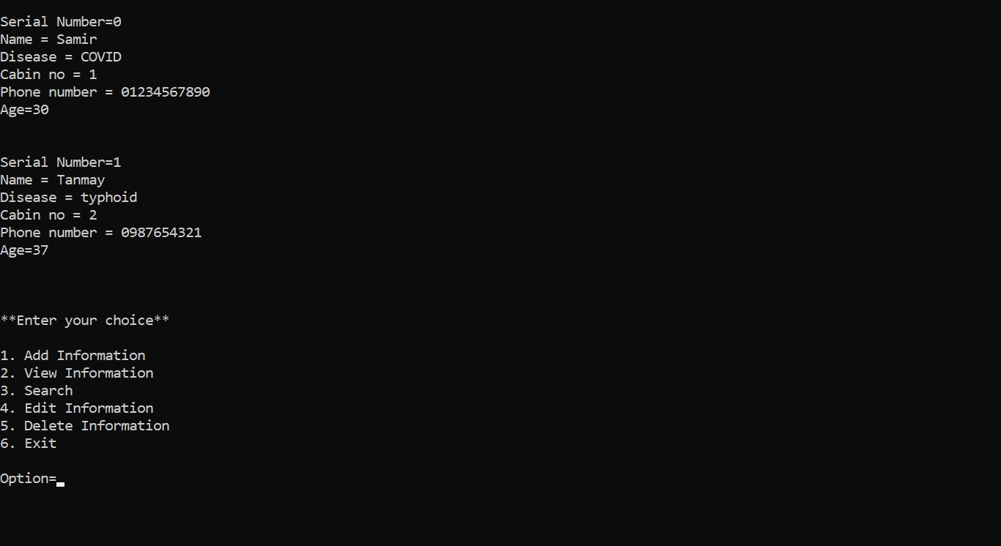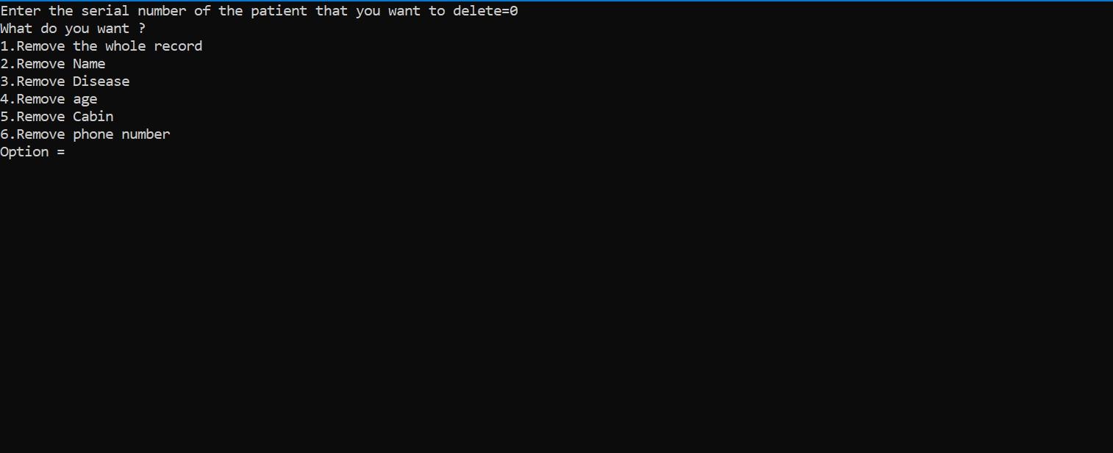

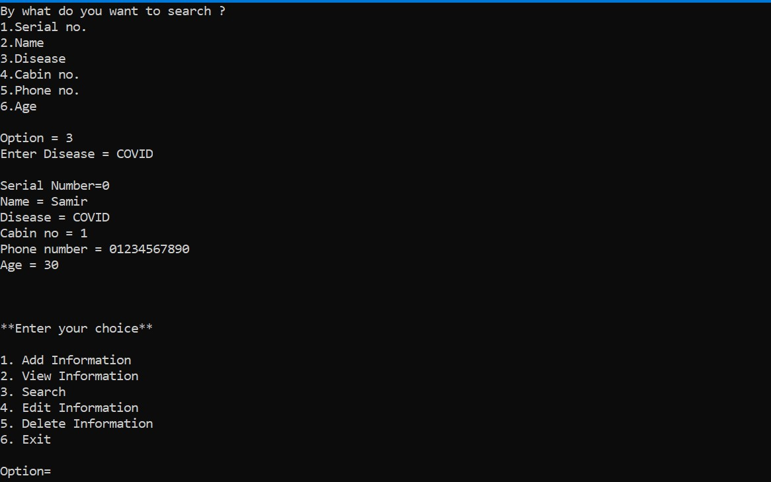

**DECLARATION :**

We hereby declare that the project entitled “Hospital Management System” submitted by Vemuru Charith and Viraj Joshi to SRM Institute of Science and Technology. We would like to thank our faculty Dr. A Vijay Vasanth for the guidance throughout the process of making this project .

**THANK YOU**